Hypothesis 1: The "Speeding" Bot
- The Logic: A human needs time to sleep and eat. A bot does not.
- The Variables (from Excel): beh_uploads_last_24h
- The Rule: If beh_uploads_last_24h is higher than 25, it is likely a bot.
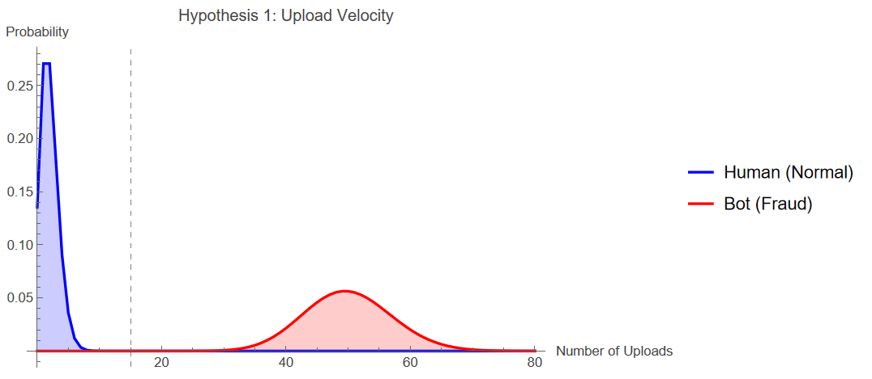
Hypothesis 2: The "Location Liar"
- The Logic: A fraudster claims to be in a high-paying country (UK/USA) but is actually hiding behind a server or VPN.
- The Variables (from Excel): id_country_declared, id_signup_ip_datacenter_flag, id_country_ip_mismatch_flag.
- The Rule: If id_country_declared says "UK" BUT id_country_ip_mismatch_flag is TRUE OR id_signup_ip_datacenter_flag is TRUE, flag for review.
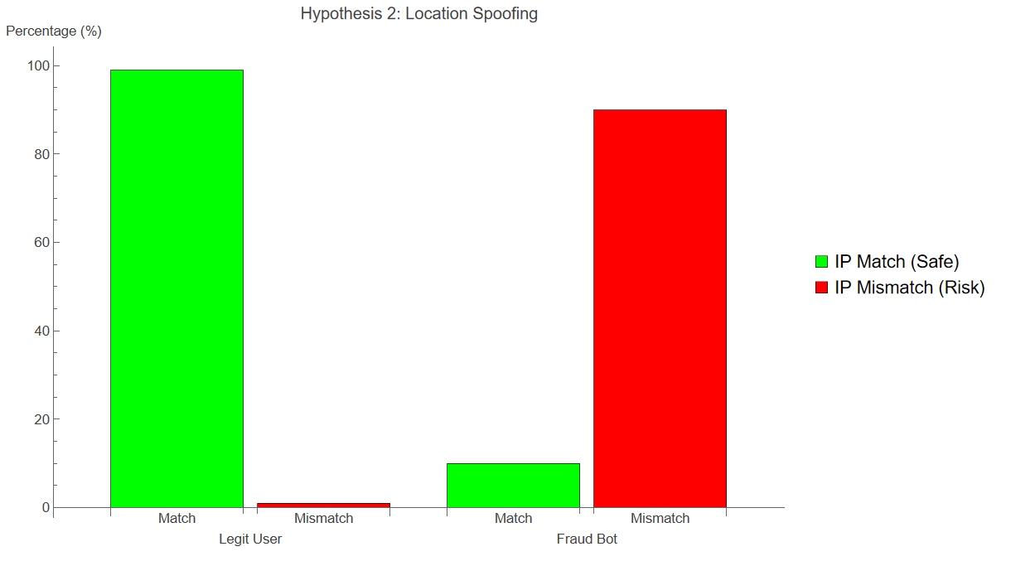
Hypothesis 3: The "Lazy Thief" (Metadata Spam)
- The Logic: A fraudster wants to appear in search results, so they stuff keywords into the song title.
- The Variables (from Excel): prov_metadata_keyword_spam_score.
- The Rule: If prov_metadata_keyword_spam_score is greater than 80, it is likely SEO spam.
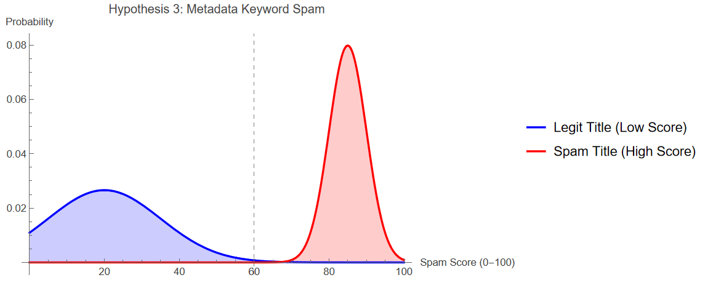

Proposed Methodology: Hybrid Detection Framework
To validate the hypotheses above, this project will implement a two-stage detection system:
Stage 1: Statistical Thresholding (The Baseline)
- Objective: To establish a deterministic baseline for "obvious" fraud.
- Technique: We will implement the Poisson and Normal Distribution models visualized above. By calculating the Cumulative Distribution Function (CDF) for each user's activity, we can mathematically determine the probability of their behavior occurring by chance.
- Application: Any user falling into the extreme tail (p < 0.01) of the distribution—e.g., exceeding 15 uploads/day or having a Spam Score > 60—will be flagged.
Stage 2: Unsupervised Anomaly Detection (The Innovation)
- Objective: To detect "Low-and-Slow" bots that intentionally stay just below the Stage 1 thresholds (e.g., uploading 14 songs to avoid the 15-song limit).
- Technique: We will utilize Isolation Forests (iForest). Unlike standard classification which requires labeled "Fraud" data (which we lack), iForest works by isolating data points that are "few and different" in high-dimensional space.
- Justification: This method is widely cited in Financial Fraud Literature (Liu et al., 2008) for detecting anomalies in sparse datasets, making it an ideal proxy for the Music Metadata domain.

